Live Q&A 2 Transcript
[I left out a lot of the simplification steps Odinaldo did in the live questions for my convenience. You can find out how to simplify these steps in Lecture 2, which you should watch.]

Live sessions
These live sessions are a way to interact and go through the material, or spend a little more time explaining. In these live sessions, I will cover mostly the material of that week’s content. For example, last week I went over through some of the material from that week last week.
This does not mean we won’t be able to revisit the material we haven’t seen before. For example, I will revisit last week this session.

Should I be reading the next week this week?
By tomorrow onward, you should have the material for next week. This means that tomorrow, you should be working on that material. By the time you finished the week, you should be up to date.
This week, your SGTs are about last week. In parallel, I expect you to be starting the material this week.
The quiz closes tomorrow night. Please do it if you can’t.

Lecture 1 Questions

Should we be reading the textbook in addition to watching the lectures for each week?
I gave you the bare minimum for a successful exam. However, if you want to elaborate, I suggest you do the further reading if you want to consolidate your knowledge that.

In the tutorial 1 sheet, “if P, then Q”, is it the same if we say “if Lenny cheats, then he gets caught” as “if he cheats, then Lenny gets caught”?
When we make these statements in propositional logic, we translate any implicit ideas from language into logic. These two things are the same.

In the tutorial 1 answer-sheet, “if P, then Q”
It is not snowing if it is below freezing
This is simple as P IMPLIES NOT Q
That it is below freezing is necessary for it to be snowing
This becomes NOT(Q AND NOT P) which can be simplified through de Morgan’s Laws to Q IMPLIES P
That it is below freezing is necessary and sufficient for it to be snowing
As this is necessary and sufficient, it contains Q IMPLIES P and P IMPLIES Q, which is the same as P IFF Q
If it is freezing, it is snowing
This is also simple. P IMPLIES Q

In the tutorial q answer sheet, write in the form “if P, then Q”
A sufficient condition for the warranty to be good is that you bought the computer less than a year ago
If you bought the computer less than a year ago, the warranty is good.
Lenny gets caught whenever he cheats
If Lenny cheats, then he gets caught

You can access the website only if you pay a subscription fee
Imagine… A: Access the website
P: Pays
A AND NOT P → Access without paying.
We are saying you can’t access without paying. So we are asking for the negation of this.
Therefore…
NOT(A AND NOT P) → A IMPLIES P
This similar transformation can be used for…
It is necessary to have a valid password to log onto the server.
See above solution.
Jan will go swimming unless the water is too cold.
Said simply, this is NOT(L AND NOT P) which simplifies to L IMPLIES P.
Finding a good job follows from learning discrete mathematics.
If you learn discrete mathematics, then you will find a good job.

[Odinaldo then went on to go through the material in Lecture 2. This is available in KEATS.
You should just watch the lectures if you really want a transcript of this part.]

Lecture 2 Questions

How do we read P AND ((Q AND R) AND S)?
This formula, structurally speaking is not the same as P AND Q AND R AND S. It is just logically the same.

How do we simply these things?
(NOT P AND NOT Q AND R) OR (P AND NOT Q AND R) OR (P AND Q AND R)
This can be simplified as (NOT Q AND R) OR (P AND R)
Semantically…
We don’t care about the truth values of each value in the brackets. We only care about what happens to the values of Q and R.
(NOT Q AND R) OR (P AND NOT Q AND R) OR (P AND Q AND R)
Similarly, we don’t care about what happens to Q as they are negated, so it can be removed.
(NOT Q AND R) OR (P AND R)
Syntactically…
(NOT P AND NOT Q AND R) OR (P AND NOT Q AND R) OR (P AND Q AND R)
This can be moved into one bracket, as…
(NOT Q AND R)

Exercise
Convert ((P IMPLIES Q) IMPLIES R) OR (NOT(P AND R) IMPLIES Q)) to DNF and CNF
Starting with DNF...
Replacing all non-DNF forms
(NOT (P IMPLIES Q) OR R) OR (NOT NOT (P AND R) OR Q)
(NOT (NOT P OR Q) OR R) OR ((P AND R) OR Q)

de Morgan’s Law
((NOT NOT P AND NOT Q) OR R) R ((P AND R) OR Q)
((P AND NOT Q) OR R) OR ((P AND R) OR Q)
(P AND NOT Q) OR R OR (P AND R) OR Q → Disjunctive Normal Form

For CNF…
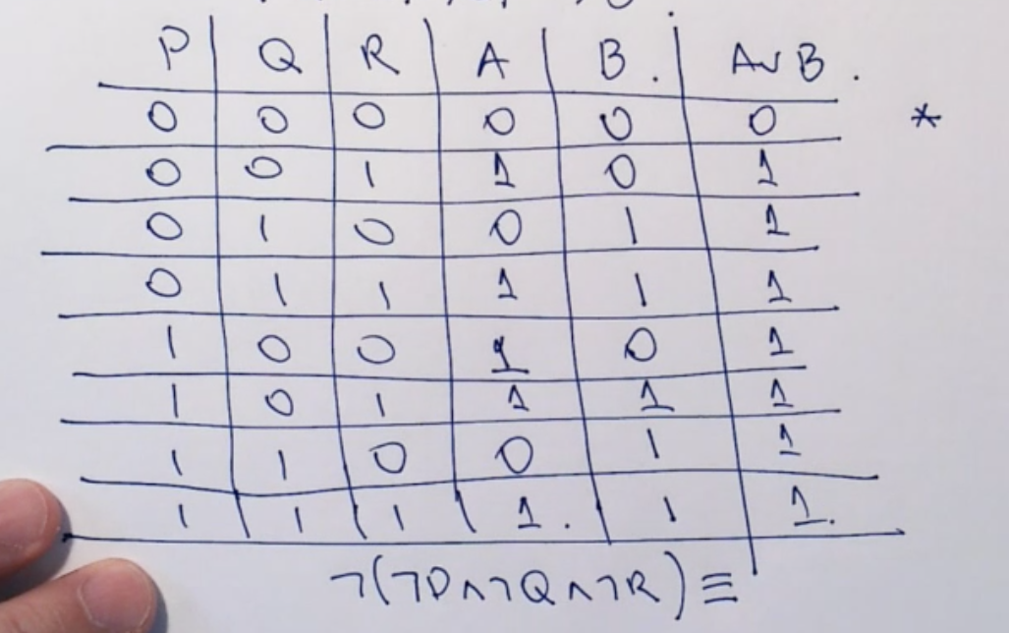

Simplifying the formula will give simply P AND Q AND R
This is logically equivalent to DNF.

